|  |  |
| --- | --- |
|  | **EPITA International Programs** |
| Fundamental semester – Msc – 2019 |
| **JAVA Fundamental: OOA & UML & Java** |

**TRAN Thi-Thuong-Hoai** thithuonghoaitran@gmai.com

**TECHNICAL SPECIFICATION**

### **Introduction**

Fun-Quiz is a simple and useful application, is designed to evaluate the knowledge of the students. Each student has his own id and password to get access his quiz and to pick their own level of question. It’s an easy usage for student and especially for teacher because the system has all the correct answers. The student will give them the grade as soon when they finish their own quiz. Also, the application will provide the student with the correction and the explanations.

### **System Specifications**

* Java SDK: Java 1.8.0
* Database: H2
* Operating System: Mac OS X
* IDE: Eclipse

1. Scope

* Generate quiz base on topics selected by the student.
* Generate quiz base on the difficulty of question selected by student.
* Automatic evaluation quality of the students when they finish their quiz.

1. Limitations

* App provided for only the student, not for the admin
* This app can’t evaluate for the answers of the Open Question from students.

### **UML Class Diagram**

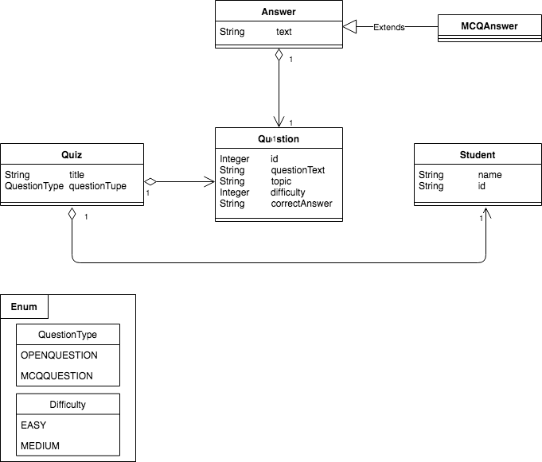

### **Global activity diagram**

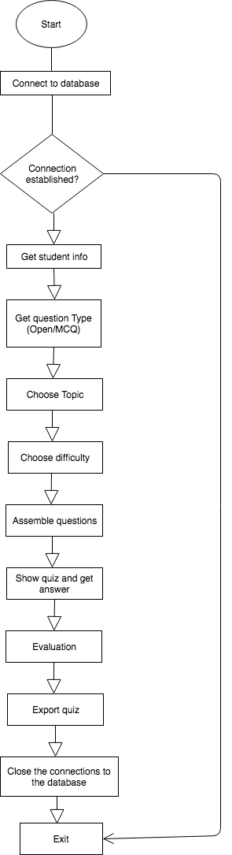

### **Overview of our programing application**

1. **Assemble question**

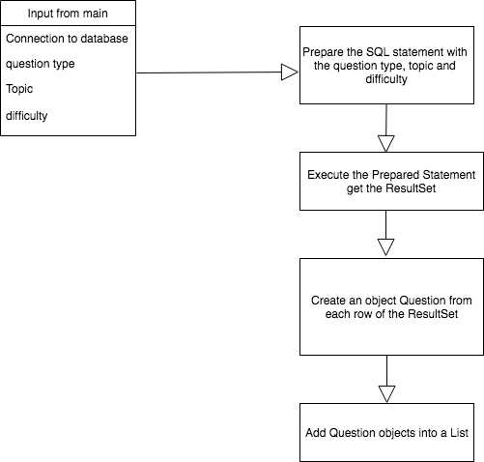

1. **Show quiz and get answer**

